**P230/2 ENTREPRENUERSHIP EDUCATION**

**U.A.C.E UTEC MOCK 2022**

**MARKING GUIDE**

*1a) contents of a well prepared job description include;*

* *Title showing business name, address plus statement job description for sales manage*
* *Job title i.e sales manager*
* *Department*
* *Nature of reporting / reporting relationship or supervisor*
* *Duty station*
* *Job summery / purpose of the job*
* *Job duties and responsibilities / key result areas (K.R.A)*
* *Equipment to be used.*
* *Job relations to other departments or jobs*
* *Working conditions*

*Any 6 x 1 = 6 marks*

*b) A well prepared job advert should include the following.*

* *Name and address of the business*
* *Business logo*
* *Document high light*
* *Job title*
* *Duty station*
* *Job summary*
* *Duties and responsibility*
* *Nature of reporting*
* *Working experience*
* *Academic qualification*
* *Salary / remuneration*
* *Age*
* *Sex*
* *Nature of the job i.e. contract / permanent (terms of employment)*
* *Marital status*
* *Working condition*
* *Special skills i.e. computer literate*
* *Place of residence*
* *Telephone contacts of the business*
* *Deadline for submission*

***Any 14x½ = 07 marks***

*c) The supply schedule should show the following.*

* *Title showing business name and address + statement, Supply schedule for the products*
* *Day / date column*
* *Items / products to be supplied*
* *Place / market*
* *Quantity*
* *Vehicle number / delivery means*
* *Person in charge*
* *Remarks / comments*
* *Endorsement / prepared by*
* *Approved by*

***Title = 01***

***Any 5 x 1 = 5 = 6 marks***

*d) The appointment letter should reflect the following.*

* *Name and address of the business*
* *Date i.e. between July and August*
* *Our ref: …..*
* *Your ref: ….*
* *Inside address*
* *Salutation (Dear sir)*
* *Reason for writing the letter*
* *Body (state the reason for writing, conditions of work, expected date of response / repl / remuneration*
* *Conclusive remark*
* *Endorsement (your faithfully)*
* *Carbon copies (e.g managing director)*
* *Enc. Copy of rules and regulations.*

*12 x ½ = 6 marks*

*2a) A well prepared production plan should include the following.*

* *Title showing business name and address + statement, production plan*
* *Business premises and location*
* *Manufacturing process / production process flow*
* *Machinery, tools and equipment to be used in production*
* *Raw materials required*
* *Plant capacity*
* *Production standards/ quality standards to be observed.*
* *Labour requirements.*
* *Utilities needed in production.*
* *Product packaging and storage*
* *Transport management*
* *Research and development*
* *Waste products management / disposal*

***Any 7 x 1 = 07***

*b) The human resource plan should include the following.*

* *Title showing business name and address plus statement human resource plan*
* *Workers needed / number of employees*
* *Academic qualification of each category of workers*
* *Duties / tasks to be performed by each category of workers*
* *Salary / remuneration*
* *Fringe benefits to be given*
* *Organizational structure / reporting line*
* *Monitoring and evaluation of workers*
* *Disciplinary policy*
* *Training of workers*
* *Promotion procedure*
* *Summary of administrative expense*

***Any 6 x 1 = 06 marks***

***NB: A candidate should use present simple tense. (is / are)***

*c) A site plan of any business should show the following*

* *Name and address*
* *Business logo*
* *Document highlight*
* *The gate (both entrance and exit where applicable)*
* *The security house/ point*
* *Parking*
* *Administration block*
* *Production area*
* *Storage facilities*
* *Recreational ground*
* *Common places e.g. Dining, canteen etc*
* *Place of convenience*
* *Campus direction*
* *Outside measurements in metres or feet e.g. 50ft by 180ft*
* *The main road.*

***Any 14x½=07 marks***

*d) The basis for developing guidelines for promoting quality output include the following*

* *Business name and address plus statement guidelines for promoting quality output*
* *Use of quality raw materials*
* *Having/ giving proper production specifications/instructions*
* *Employing quality manager/ monitoring production.*
* *Operating in a clean environment*
* *Proper packaging and storing of the products.*
* *Employing labour with the necessary skills*
* *Encouraging specialization*
* *Motivating workers*
* *Using appropriate technology*
* *Carrying out constant research*
* *Constant training of workers through workshops and seminars*
* *Proper handling of the product during distribution*
* *Following quality standards as set by quality monitoring body (UNBS).*

*Any 5x1 =05 marks*

*NB: All points should be stated using the word “shall” e.g. “the business shall purchase quality raw materials from a reliable source i.e……...”*

*3a) A cash flow statement records projected incomes and expenses of the business*

*While*

* *An income statement records the real incomes (earned money) and expenses (money spent).*
* *Cash flow statement is used to make cash projections*

*While*

* *An income statement is used to make investment decisions*
* *Cash flow statement is occasionally prepared during the financial year i.e. monthly, quarterly or annually*

*While*

* *An income statement i.e. prepared once at the end of the financial period.*
* *A cash flow statement is prepared to determine the net cash position of the business*

*While*

* *An income statement is prepared to determine the business’ net profit for the year*
* *A cash flow statement is used to record cash transactions only i.e. cash received or spent*

*While*

* *An income statement records both cash and credit transactions.*

***Any 2x2 =04 marks***

*a)ii) DEVINE MERCY CONFECTIONARIES’*

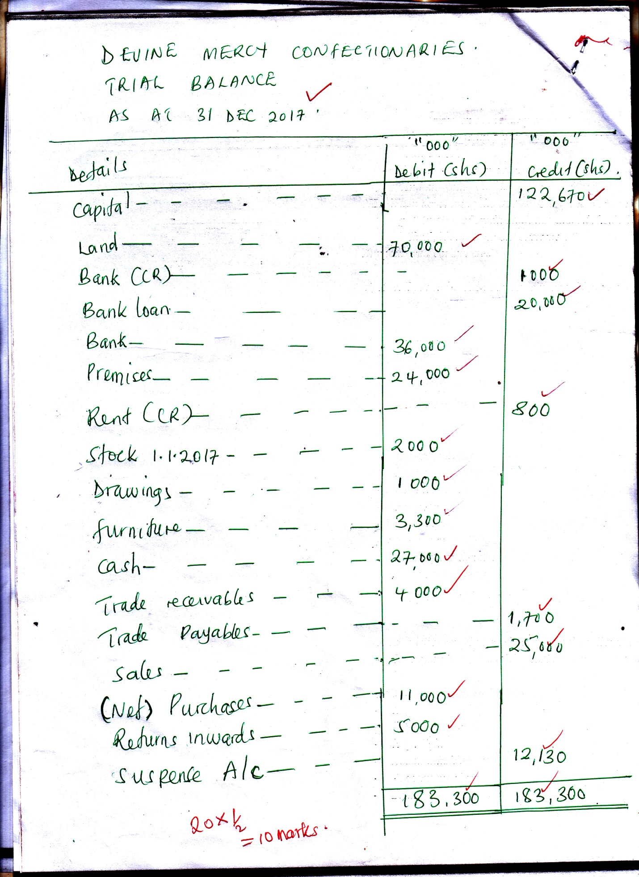

*b(i) inventory turnover ratio= $\frac{cost of sales}{Average stock}$*

*But: cost of sales =opening stock+ Net purchases- closing stock*

*= (2,000,000 + 11,000,000)- 1,500,000*

*=13000000-1,500,000*

*= 11,500,000*

*Also; Average stock= $\frac{opening stock+closing stock}{2}$*

*= $\frac{2,000,000+1,500,000}{2}$*

*= $\frac{3,500,000}{2}$*

*= shs.1, 750,000*

*Inventory turnover ratio= $\frac{11,500,000}{1,750,000}$*

*= 6.6*

*=7 times*

*(ii) Cash ratio = $\frac{Absolute liquid assets}{current liabilities}$*

*= $\frac{cash+bank}{Bank\left(cr\right)+ Trade payables+Electrity in Areas}$*

*= $\frac{2,700,000+36,000,000}{1000,000+1,700,000+550,000}$*

*= $\frac{63,000,000}{3,250,000}$*

*= 19.4: 1*

*≈ 19:1*

*(iii) Credit payment period = $\frac{Tradepayables}{net purchases}$ x Number of days in a year*

*= $\frac{1,700,000}{20,000, 000 }$ x 365 days*

*= 56.4 = 56 days*

***TT=03 mks***

*(iv) Stock turnover period = $\frac{Averagestock}{costofsales}$ x Number of days in a year*

*= $\frac{1,750,000}{11,500,000}$ x 365*

*= 55.5*

*= 56 days*

*4(a) title*

* *Title showing business name and address plus statement credit policy for the SACCO*
* *Loan amount*
* *Interest to be charged eg 5%, 2%*
* *Repayment period (credit period)*
* *Collateral/ security in form of fixed assets*
* *Proper identification of the borrower e.g. valid identity card*
* *Maximum number of installments payable shall be…..*
* *Priority shall be given to….. (Sector, gender, disabled)*
* *Authorization of the loan amount*
* *Charges to be involved e.g. loan processing fee*
* *Guarantors*
* *Loans shall be extended to only members with active accounts in the SACCO*
* *Loans shall be given to those in ……. Specify the area)*
* *Purpose of the loan shall be specified at the time of applying for the loan*
* *Penalty in case of defaulting*

*NB: When developing the above policy, the word “shall” should be used*

*E.g. “Amount of credit shall not exceed shs.5, 000,000 for the first time borrowers and*

*Shs.3,000,000 for old customers”.*

*title = 01*

*5* ***x1 = 05mks = 6 marks***

*bi) A well prepared cash deposit slip should have the following*

* *Name and address of the business*
* *Business logo*
* *Document number*
* *Date (left blank)*
* *Document name*
* *Account name*
* *Account number*
* *Amount deposited*
* *Counter signing offices*
* *Bank stamp*
* *Endorsement*
* *Boundary / frame*

*Name of the depositor*

*Telephone contact*

*Signature of the depositor*

***Any 12x½ = 06 mks***

*bii) A cash withdrawal form should have the following.*

* *Name and address of the business*
* *Date*
* *Logo*
* *Form number*
* *High light (document name)*
* *Account holders’ name*
* *Account number*
* *Branch*
* *Amount in words and*
* *Amount in figures*
* *Customer’s signature*
* *Bank stamp*
* *Boundary / frame*
* *Customers phone number or contact*

***Any 12x½ = 06 marks***

*c) NO POVERTY SACCO’S LOAN REPAYMENT SCHEDULE*

|  |  |  |  |  |  |  |  |  |  |  |  |  |  |  |  |  |  |  |  |  |  |  |  |  |  |  |  |  |  |  |  |  |  |  |  |  |  |  |  |  |  |  |  |  |  |  |  |  |  |  |  |  |  |  |  |  |
| --- | --- | --- | --- | --- | --- | --- | --- | --- | --- | --- | --- | --- | --- | --- | --- | --- | --- | --- | --- | --- | --- | --- | --- | --- | --- | --- | --- | --- | --- | --- | --- | --- | --- | --- | --- | --- | --- | --- | --- | --- | --- | --- | --- | --- | --- | --- | --- | --- | --- | --- | --- | --- | --- | --- | --- | --- |
| *NO POVETY SACCO*  *P.O BOX 82,*  *WAKISO*  *TEL:078444222/0702444222*  *Email: Nopovertysacco@yahoo.com*  *Providers of quick loans, development loans etc*     |  | | --- | | *LOAN REPAYMENT SCHEDULE* |   *LOAN AMOUNT: SHS.8,000,000*  *INTEREST: 2% per month*  *REPAYMENT PERIOD: 8 months Method of calculating interest*  *CUSTOMERS NAME: NAMYENA DAPHINE (Reducing balance method)*   |  |  |  |  |  | | --- | --- | --- | --- | --- | | *INSTALMENTS* | *PRINCIPAL* | *INTEREST* | *TOTAL REPAYMENT* | *BALANCE* | |  | *SHS* | *SHS* | *SHS* | *SHS* | | *1st installment* | *1,000,000* | *160,000* | *1,160,000* | *7,000,000* | | *2nd installment* | *1,000,000* | *140,000* | *1,140,000* | *6,000,000* | | *3rd installment* | *1,000,000* | *120,000* | *1,120,000* | *5,000,000* | | *4th installment* | *1,000,000* | *100,000* | *1,100,000* | *4,000,000* | | *5th installment* | *1,000,000* | *80,000* | *1,080,000* | *3,000,000* | | *6th installment* | *1,000,000* | *60,000* | *1,060,000* | *2,000,000* | | *7th installment* | *1,000,000* | *40,000* | *1,040,000* | *1,000,000* | | *8th installment* | *1,000,000* | *20,000* | *1,020,000* |  | | *Totals* | ***8,000,000*** | ***720,000*** | ***8,720,000*** |  |   *Prepared by APPROVED BY*  *SEMULYA ALEX ……………………………..*  *LOAN OFFICER ………………………………………..* |

***Any 14 ticks x ½ =07 marks***

*5*

*a(i) Tax evasion is the deliberate refusal by the tax paying unit to pay tax imposed*

*OR*

*It is the deliberate refusal /concealment/ misrepresentation of the true state of one’s financial position to the tax authority so as to reduce his/her tax liability.*

*While*

*Tax avoidance is the deliberate and legal refusal of the tax paying unit to meet its tax obligations by taking advantage /exploiting the loopholes in the tax system.*

***02 marks***

*(ii) Under declaring of one’s income*

* *Overstating of expenses*
* *Understating of one’s profits*
* *Smuggling*
* *Hiding from tax collectors*
* *Capitalization of one’s profits*
* *Complete refusal to declare one’s wealth, income or property.*

***Any 5x1= 05 marks***

*b) VAT Liability = tax – input tax*

*V.A.T on inputs (raw materials) = $\frac{18}{100}$ x 45,800,000*

*=shs. 8,244,000*

*V.A.T on output = $\frac{18}{18+100}$ x final cost/selling price*

*= $\frac{18}{18+100}$ x 82,600,000*

*= shs.12, 600,000*

***TT= 02 marks***

*OR*

*Let the original cost be x*

*V.A.T rate +1x x= selling price*

$\frac{18}{100}$*+ 1x x = 82,600,000*

*0.18 + 1x x =82,600,000*

*1.18x = 82,600,000*

$\frac{1.18x}{1.18}$*= $\frac{82,600,000}{1.18}$*

*x =70,000,000*

*V.A.T chargeable= selling price –cost price*

*= 82,600,000-70,000,000*

*=shs.12, 600,000*

*TT= 02 marks*

*V.A.T liability = output V.A.T – Input V.A.T*

*= 12,600,000 – 8,244,000*

*= shs.4, 356,000*

***Total mark = 06***

*c(ii) Monthly total rental income =500,000x 4=shs.2,000,000*

*Annual rental income = Monthly rental income x 12 months*

*= shs.2, 000,000 x12*

*= shs.24, 000,000*

*Chargeable income = Annual rental income- Allowable deductions*

*Where allowable deductions = costs + expenses incurred + Threshold*

*Costs and expenses incurred = $\frac{20}{100}$ x24, 000,000*

*= shs. 4,800,000*

*Threshold = 2,820,000 shillings*

*Chargeable rental income = 24,000,000- (4,800,000 + 2,820,000)*

*= 24,000,000- 7620,000*

*Chargeable income = shs. 16,380,000*

*(ii) Rental tax = chargeable rental income x rental tax*

*= $\frac{20}{100}$ x 16,380,000*

*= shs.3, 276,000*

*6*

*(a) A well developed programe for becoming a social entrepreneur should include the following;*

* *Title showing business name and address plus a statement program for becoming a social entrepreneur.*
* *Activity column*
* *Time column*
* *Officer responsible*
* *Remarks*
* *Endorsement (prepared by…………, Approved by………….)*

***Total marks= 06***

***Activities***

* *Developing the idea of becoming a social entrepreneur*
* *Developing vision, passion and skills for becoming social ent.*
* *Identifying opportunities in the environments*
* *Matching the vision with opportunities available in the community*
* *Acting and spreading change*
* *Mobilizing the resources*
* *Completing all legal formalities*
* *Constructing all needed building*
* *Purchasing and installing the necessary machinery, equipments*
* *Recruiting of the workers*
* *Carrying out production trial*
* *Launching the social enterprise*
* *Starting operations*

*b) KAMAGU ENVIRO-KLEAN LTD’S GEPIC STRUCTURE OF ADVOCACY*

|  |  |
| --- | --- |
| *KAMAGU ENVIRO-KLEAN LTD*  *P.O BOX 1860,*  *WAKISO*  *TEL. 0702003322/0772003322*  *E-Mail: Kamagu enviro-klean@ yahoo.com*  *Dealers in rubbish collection and general cleanliness.*     |  | | --- | | *GEPIC STRUCTURE OF ADVOCACY* |   *Greet. Dear members of Wakiso town,I greet you and welcome you to this special gathering this evening.*  *Engage. In 2016, daily monitor newspaper reported that 20 people died in Mbale due to diseases related to poor sanitation. Also C.N.N reported that several people were hospitalized in Rwanda suffering from hygiene related diseases such as cholera*  *.*  *Problem statement: Presently, Uganda and particularly Wakiso town is faced with hygiene challenge were the entire town is littered with rubbish. This is causing a major health problem and it is likely to result into several deaths.*  *Inform. This purpose of this meeting therefore, is to make you aware of a newly formed enterprise called Kamagu Enviro-Klean ltd, formed to assist keeping our town in good condition*  *Challenge/ call for action. I therefore invite you to be part of this organization as we struggle to keep Wakiso clean.*  *Prepared by;*  *NAVUGA PERSIS*  *EXECUTIVE DIRECTOR* |

*C) KAMAGU ENVIRO-KLEAN LTD’S THEORY OF CHANGE*

|  |  |
| --- | --- |
| *KAMAGU ENVIRO-KLEAN LTD*  *P.O BOX 1860,*  *WAKISO.*  *TEL. 0702003322/ 0772003322*  *Email: Kamaguenviro-kleanltd@yahoo.com*  *Dealers in rubbish collection and general cleanliness*  *DATE: 1st JUNE 2018*   |  | | --- | | *THEORY OF CHANGE* |   *Vision statement. “To make Wakiso a role model town in promoting hygiene in Uganda”*  *Impact. “To create a rubbish free town through continuous sensitization of the people and general involvement of the entire public. This will involve use of community leaders at different levels.*  *Outcomes. About 98% of Wakiso town dwellers will be helped to change their mind-set towards working for a better and clean environment.*  *Activities. Kamagu enviro-klean Ltd will directly get involved in collecting rubbish at a low cost, sensitization workshops will be organized in different parts of the town and dustbins will be put in different corners to facilitate proper disposal of rubbish.*  *Inputs. The enterprise will require big dust bins, buckets spades and motor vehicles to carry the rubbish to a central disposal point.*  *Prepared by*  *NABIRYO ANGELLA*  *PROJECT MANAGER.* |

***Total marks=07***

*d) - the introduction which includes the title, vision statement and summary of the enterprise.*

* *Theory of change involving explanation of the vision, impact to be created, outcomes, activities and inputs required.*
* *The opportunity involving impact area, current reality research, impact potential etc*
* *The innovation involving root cause analysis, product description and innovation matrix.*
* *Management and operations involving management roles and responsibilities, strategic partners, impact on environment etc*
* *Project sustainability involving drawing budgets, highlighting the source of funds, profit management etc*

*Any 5x1 =05 marks*

***END***